LABORATORIYA ISHI №4
Mavzu: PHP orqali MySQL ma’lumotlar bazasiga ulanish

1. Ishning maqsadi
- Tayyor MySQL bazaga PHP orqali ulanish
- SELECT so‘rovlarini bajarish
- INNER JOIN orqali bir nechta jadval ma’lumotlarini chiqarish
- MySQLi (procedural, OOP) va PDO usullarini taqqoslash
- Ular orasidagi farqlarni amaliy ko‘rsatish

2. Nazariy qism
PHP orqali MySQL bilan ishlashning 3 asosiy usuli mavjud:
- MySQLi (Procedural)
- MySQLi (Object-Oriented)
- PDO (PHP Data Objects)


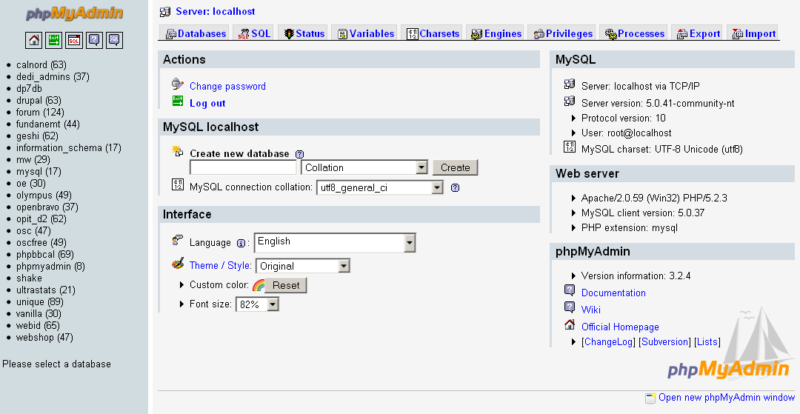

3. Amaliy baza (tayyor database)
Database: db_universitet
3 ta jadval:
fakultetlar
- id (PK)
- nomi
talabalar
- id (PK)
- ism
- kurs
- fakultet_id (FK)
fanlar
- id (PK)
- fan_nomi
- kredit
- talaba_id (FK)

4. Oddiy SELECT so‘rovi
SELECT * FROM talabalar;

5. JOIN so‘rovi
SELECT
talabalar.ism,
talabalar.kurs,
fakultetlar.nomi AS fakultet,
fanlar.fan_nomi
FROM talabalar
INNER JOIN fakultetlar ON talabalar.fakultet_id = fakultetlar.id
INNER JOIN fanlar ON talabalar.id = fanlar.talaba_id;

6. PHP orqali ulanish usullari
6.1 MySQLi – Procedural usul
<?php
$conn = mysqli_connect("localhost", "root", "", "db_universitet");
if (!$conn) {
die("Ulanish xatoligi: " . mysqli_connect_error());
}
$sql = "SELECT * FROM talabalar";
$result = mysqli_query($conn, $sql);
while ($row = mysqli_fetch_assoc($result)) {
echo $row['ism'] . " - " . $row['kurs'] . "<br>";
}
mysqli_close($conn);
?>
Xususiyatlari:
- Oddiy
- Faqat MySQL bilan ishlaydi
- Xavfsizlik PDO ga qaraganda pastroq
6.2 MySQLi – Object Oriented usul
<?php
$conn = new mysqli("localhost", "root", "", "db_universitet");
if ($conn->connect_error) {
die("Xatolik: " . $conn->connect_error);
}
$sql = "SELECT * FROM talabalar";
$result = $conn->query($sql);
while ($row = $result->fetch_assoc()) {
echo $row['ism'] . "<br>";
}
$conn->close();
?>
Xususiyatlari:
- OOP yondashuv
- Professionalroq
- Katta loyihalar uchun qulay
6.3 PDO usuli (Tavsiya etiladi)
<?php
try {
$conn = new PDO("mysql:host=localhost;dbname=db_universitet", "root", "");
$conn->setAttribute(PDO::ATTR_ERRMODE, PDO::ERRMODE_EXCEPTION);
$sql = "SELECT * FROM talabalar";
$stmt = $conn->query($sql);
while ($row = $stmt->fetch(PDO::FETCH_ASSOC)) {
echo $row['ism'] . "<br>";
}
} catch(PDOException $e) {
echo "Xatolik: " . $e->getMessage();
}
?>
Xususiyatlari:
- Turli DB lar bilan ishlaydi (MySQL, PostgreSQL, Oracle)
- Eng xavfsiz
- Prepared Statement kuchli
- try-catch bilan ishlaydi

7. PDO orqali JOIN misoli
<?php
try {
$conn = new PDO("mysql:host=localhost;dbname=db_universitet", "root", "");
$conn->setAttribute(PDO::ATTR_ERRMODE, PDO::ERRMODE_EXCEPTION);
$sql = "SELECT
talabalar.ism,
talabalar.kurs,
fakultetlar.nomi AS fakultet,
fanlar.fan_nomi
FROM talabalar
INNER JOIN fakultetlar
ON talabalar.fakultet_id = fakultetlar.id
INNER JOIN fanlar
ON talabalar.id = fanlar.talaba_id";
$stmt = $conn->query($sql);
echo "<table border='1'>";
echo "<tr><th>Ism</th><th>Kurs</th><th>Fakultet</th><th>Fan</th></tr>";
while ($row = $stmt->fetch(PDO::FETCH_ASSOC)) {
echo "<tr>
<td>{$row['ism']}</td>
<td>{$row['kurs']}</td>
<td>{$row['fakultet']}</td>
<td>{$row['fan_nomi']}</td>
</tr>";
}
echo "</table>";
} catch(PDOException $e) {
echo "Xatolik: " . $e->getMessage();
}
?>

8. Usullarni taqqoslash
Xususiyat | MySQLi Procedural | MySQLi OOP | PDO
DB turi | Faqat MySQL | Faqat MySQL | Ko‘p DB
Xavfsizlik | O‘rtacha | Yaxshi | Eng yaxshi
try-catch | Yo‘q | Yo‘q | Bor
Prepared | Bor | Bor | Juda kuchli
Professional | O‘rtacha | Yaxshi | Eng yaxshi

9. Natija
Laboratoriya ishida:
- Tayyor MySQL bazaga ulanish amalga oshirildi
- SELECT so‘rovi bajarildi
- INNER JOIN ishlatildi
- 3 xil PHP usuli taqqoslandi
- PDO eng tavsiya etiladigan usul ekanligi ko‘rsatildi
Topshiriqlar:

15-Universitet yotoqxona
Database: db_yotoqxona

Jadvallar:
talabalar
- id
- ism
- kurs
xonalar
- id
- xona_raqam
- qavat
joylashuv
- id
- talaba_id (FK)
- xona_id (FK)
- sana

JOIN vazifa:
Talaba + Xona raqami + Qavat chiqarish.

Talaba nima qiladi?
- Joylashuv jadvali orqali bog‘laydi
- INNER JOIN yozadi
- SELECT natijasini chiqaradi

CREATE DATABASE db_yotoqxona;
USE db_yotoqxona;

-- Talabalar jadvali
CREATE TABLE talabalar (
id INT AUTO_INCREMENT PRIMARY KEY,
ism VARCHAR(100) NOT NULL,
kurs INT NOT NULL
);

-- Xonalar jadvali
CREATE TABLE xonalar (
id INT AUTO_INCREMENT PRIMARY KEY,
xona_raqam VARCHAR(10) NOT NULL,
qavat INT NOT NULL
);

-- Joylashuv jadvali
CREATE TABLE joylashuv (
id INT AUTO_INCREMENT PRIMARY KEY,
talaba_id INT,
xona_id INT,
sana DATE,
FOREIGN KEY (talaba_id) REFERENCES talabalar(id),
FOREIGN KEY (xona_id) REFERENCES xonalar(id)
);

INSERT INTO talabalar (ism, kurs) VALUES
('Ali', 1),
('Vali', 2),
('Hasan', 3);

INSERT INTO xonalar (xona_raqam, qavat) VALUES
('101', 1),
('202', 2),
('303', 3);

INSERT INTO joylashuv (talaba_id, xona_id, sana) VALUES
(1, 1, '2025-02-01'),
(2, 2, '2025-02-02'),
(3, 3, '2025-02-03');

Config.php
<?php
$servername = "localhost";
$username = "root";
$password = "";
$dbname = "db_yotoqxona";

$conn = new mysqli($servername, $username, $password, $dbname);

if ($conn->connect_error) {
die("Ulanishda xatolik: " . $conn->connect_error);
}
?>
Index.php
<?php
include "config.php";

$sql = "SELECT talabalar.ism, xonalar.xona_raqam, xonalar.qavat
FROM joylashuv
INNER JOIN talabalar ON joylashuv.talaba_id = talabalar.id
INNER JOIN xonalar ON joylashuv.xona_id = xonalar.id";

$result = $conn->query($sql);
?>

<!DOCTYPE html>
<html>
<head>
<title>Universitet Yotoqxona</title>
</head>
<body>

<h2>Talabalar joylashuvi</h2>

<table border="1">
<tr>
<th>Talaba ismi</th>
<th>Xona raqami</th>
<th>Qavat</th>
</tr>

<?php
if ($result->num_rows > 0) {
while($row = $result->fetch_assoc()) {
echo "<tr>
<td>".$row['ism']."</td>
<td>".$row['xona_raqam']."</td>
<td>".$row['qavat']."</td>
</tr>";
}
} else {
echo "<tr><td colspan='3'>Ma'lumot topilmadi</td></tr>";
}
?>

</table>

</body>
</html>
